Section | Content | Words
01- Introduction | Introduction to Power BI  Purpose of the Dashboard  Objectives of the reports | 120-150
02- Dataset Description | Describe the Data Source  Type of Data  Number of Records  Key Variables  Any Preprocessing Performed | 150-180
03- Dashboard Design and Development | Explain How the Dashboard was Created  Data Modelling  Relationships  DAX Measures  Filters, Slicer, Charts and Design Choices | 220-250
04- Dashboard Features and Visualisation | Describe each visualisation (bar chart, line chart, pie chart, KPI cards, maps, tables, etc.)  explain why it was used. | 180-200
05- Key Insights and Analysis | Discuss the major findings obtained from the dashboard.  Highlight trends, comparisons, KPIs and business insights. | 180-200
06- Challenges and Limitations | Mention data quality issues, missing values, and visualisation limitations  Technical challenges encountered. | 70-100
07- Conclusion and Recommendations | Summarise the report  Provide recommendations for future improvements or business decisions. | 80-100

Power BI Sales Dashboard Explanation Report

Introduction to Power BI: -
Power BI is a dynamic and powerful business analytics tools designed to provide data-driven insights that help us to make good decisions and actions. The three main components are Power BI Desktop, Power BI service, and Power BI Mobile.
Both Power BI Desktop and Power BI service are integral parts of the Power BI ecosystem.

Purpose of Power BI Dashboard:-
The main goal of this Sales Analysis Dashboard is to help us track our sales performance across global regions. By putting all our transaction data in one place it makes it easy to see which regions are doing great how our sales are performing what products people are buying and how customers like to pay. This report breaks down how I understood the dashboard design, what the visuals show and some insights.
  - Objective of Reports:-

Keep Track of Our Sales: We want to Keep Track of Our Sales. We need to see how much money we are making how many orders are coming in and the average amount customers spend to make sure we are achieving our regional targets.
Find What's Working Best: We need to spot our performing sales reps and see which products are favourites in different areas so we can keep pushing those items.
Help Plan Ahead: We need to look at sales ups and downs over time so our marketing team knows the months to run big promotions and our inventory team knows when to stock up.

Describe the Data Source Type of Data, Number of Records, Key Variables, and Any Preprocessing Performed.

For this analysis, I looked closely at the data file named Product-Sales-Region.xlsx. Inside the Sales sheet, there are exactly 1,500 rows of data and 19 columns to work with. Some of the columns I used for this report are Date, Region, Product, Quantity, Unit Price, Total Sales, Store Location, Payment Method, and Salesperson.

I did a quick check on the data quality to see if we needed to do any cleaning. The good thing is that the core columns like sales, products, and regions have absolutely no missing values, so the data is very good. The only thing I noticed is that the Promotion column has 370 blank rows. But that is completely fine, it just means those specific customers bought items at the normal price without using any discount codes.

Explain How the Dashboard was Created: Data Modelling Relationships, DAX Measures, Filters, Slicer, Charts and Design Choices

Building and navigating this dashboard taught me a lot about data modelling in Power BI. On the left side, there is a dedicated blue sidebar for global filters. It includes easy-to-use slicers for Region, Product, Payment Method, Salesperson, and Store Location so users can filter the data however they want. There is also a handy date range slice at the top right corner to filter by specific timeframes.
One of the coolest features I discovered is cross-filtering. When you click on South America in the region bar chart, the entire dashboard automatically updates to show only South America's data. One of the key features of the Model view is managing relationships between tables. Power BI automatically detects relationships based on common fields.
To make sure our timeline reporting is completely robust, I implemented a custom, fully optimised Date Dimension Table using a calculated DAX table. Relying on standard auto-date hierarchies in Power BI can slow down performance, so I wrote this calculated table to dynamically anchor itself to our actual sales boundaries
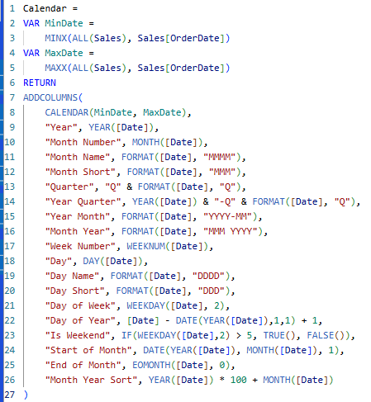
calculated DAX table formula img

Dashboard Features and Visualisations

The layout of the dashboard is really neat and easy to follow. Here is a quick breakdown of the visuals used and why they work so well:

KPI Summary Cards: These are placed right at the top so anyone can instantly see the big numbers: Total Sales, Total Profit, Profit Margin, Total Orders, and Average Order Value.

Sales Trends (Line Chart): This shows a combined view of sales and profits over time. It’s great for spotting the seasonal peak.

Region Sales (Horizontal Bar Chart): This ranks our global markets from highest to lowest. It immediately shows that North America is the biggest market, while South America is small.

Total Sales by Product & Payment Method: The bar chart shows which items are popular, and the donut chart gives a colourful breakdown of how people prefer to pay (like Online or Credit Card).

Salesperson Performance Table: A detailed grid at the bottom right that shows exactly how much revenue and profit each individual sales rep is bringing in.

Discuss the major findings obtained from the dashboard. Highlight trends, comparisons, KPIs and business insights.

Overall Performance: South America brought in a total revenue of 827,768.19. This came from 295 total orders, which means our average order value is quite strong at 2,805.99.

Timeline Trends: Looking at the line chart, sales hit a massive peak between October and December 2024. However, there was a big drop right after the holidays in January 2025, before bouncing back up in February.

Top Products: Laptops are our biggest cash cow in the region (making around 0.16M), with Chairs coming in a close second (0.15M). On the other hand, Desks are lagging behind at only 0.07M.

Payment Habits: Our customers there love digital options! Online payments are the most popular at 191.61K, with Credit Cards following close behind.

Challenges

While exploring the formulas (DAX measures) used for the KPI cards, I did notice something a bit unusual with the Profit Margin % calculation. Right now, it shows a margin of 106.88%. Usually, profit margins can't go over 100%, and looking at the numbers, Total Profit (884.72K) is actually higher than Total Sales ($827.7K). I think the formula might be inverted or accidentally multiplying by a markup factor instead of the standard profit, which is something I need help to fix in the next version.

Present DAX measure Formula I am using:
Profit Margin % =
DIVIDE(
[Total Profit],
[Total Sales],
0
)

Conclusion
To wrap things up, working on this Sales Analysis Dashboard project has been an incredible learning experience for me as a new joiner. By combining core transactional data from Product-Sales-Region.xlsx with a custom, high-performance DAX calendar table, I have built a really powerful tool that helps us see exactly how our business is moving. Looking closely at the South America region showed me how dynamic our sales trends are—like our massive end-of-year peaks, the high demand for laptops, and how much our customers love paying online. While we do have a couple of quick data modelling fixes to address, such as updating the profit margin DAX formula to reflect true business percentages, I am confident this dashboard gives the client a clear, reliable roadmap to plan smarter promotions and boost there regional sales. I can't wait to jump into the next phase, apply your feedback.

